**HCP Recruiting Data Analysis (FY23)**

**Applicant to Hire Ratio (YTD)**

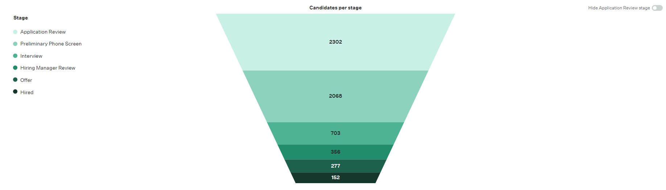

Based on the data shown here, the current applicant to hire ratio is ~15:1. In order to improve this number, we have to either increase the number of applications coming in and/or utilize specific recruitment strategies to retain individuals throughout the process. There are a few ways to go about this.

1. **Using targeted sourcing**: We can focus on sourcing strategies that target specific candidate pools such as industry-specific job boards, professional networks, and employee referrals. This can lead to more relevant applications. We have considered the use of myCNAjobs, yet they have not been yielding the ideal candidates due to unresponsiveness or a lack of commitment. We can look into a couple of other job boards that may offer a higher quality candidate pool. Glassdoor and ZipRecruiter are the two most popular and user-friendly job boards that integrate with Greenhouse. It may be beneficial to have a team member fill the role of a sourcer to actively engage with passive talent. The use of a professional network is the most effective to ensure that we hire and retain candidates, as clients from community partners are highly qualified. Lastly, setting up another outreach for employee referrals. If we hand out flyers and postcards to new hires and tenured staff, we can have them refer individuals who may be interested. A smaller incentive program may also work to help bring employees onboard (e.g. $50 gift card for those who refer a candidate and makes through NHT). This will encourage current employees to refer qualified candidates and can lead to a higher pipeline generation.
2. **Improving employer branding:** We can collaborate with the Communications team to build a strong employer image that highlights the company culture, values, and benefits. If we are able to market a positive image through outreach, we can attract more qualified candidates. While there are a lot of media in our company for employees and internal reach (HBN Newsletter), there is limited outreach that displays our employer branding aside from word of mouth. One thing to consider would be the use of social media.
3. **Utilize pre-screening questions:** We can include a required pre-screening question with the job application that states “I am aware that this role requires me to commit to New Hire Training, which runs from 8:30am-5pm on Monday-Friday for 3 weeks.” Another question to include would be “I am aware that this role requires me to work at least one weekend day every week.” These two questions would filter out candidates who are not qualified due to personal commitments and scheduling conflicts which have been extremely prevalent since the fall semester started.
4. **Measuring KPIs and optimization:** We should regularly track and analyze our current application-to-hire ratio at the end of each quarter. By doing so, we can identify bottlenecks that cause candidates to drop out of the process and look at areas of improvement, then taking steps to address these issues.
5. **Creating a more engaging onboarding process:** Although there may be a lot of barriers that may lead to candidates being withheld in the Offer stage for up to 33 days, we have to consider how we can help with engagement. Many of the candidates fall off here due to an inability to meet our expectations. A redesign of the Group Session and Pre-Hire meetings may help to reduce this number. In addition to this, the administrative burdens of our hiring process can be mitigated through the use of our new tool, Greenhouse Onboarding. Once the software is setup, we can optimize our pre-hire setup and work from there. I would highly encourage us to implement a short survey regarding the onboarding steps which would integrate with Greenhouse.

-Note: Although we see a high number of average days in the Preliminary Phone Screen and Interview stages (7 and 10 days, respectively), we have to take into account that many candidates are a no show, and/or a reschedule for the following week, and/or become unresponsive. The recruiting team moves very quickly and interacts with key stakeholders within 3 business days.

**Applicants by Source (YTD)**

We see that the majority of our candidate pool comes from Third-party boards, specifically Indeed’s sponsorship. Because this is where the bulk of our applications are, we should invest more time and money into paying a larger premium to advertise our HCP role. As it stands, Homebridge is number 5 on the job board for “Caregiver” in “San Francisco, CA.” Honor sets their job post as “Urgently Hiring,” which pushes them to the top of the search results. We can look into this and see how we can promote our job posting the same way.

Additionally, we want to edit the job location for all of the job posts on Greenhouse to match the exact location, “San Francisco, CA.” Having this small change from SF HQ may create a difference in individuals searching for jobs in the city, and we may even see a higher yield of candidates who apply directly, contributing to a higher number under “Jobs page on your website.”

Utilizing certain industry-specific job boards may be helpful, but we have not been able to yield and retain qualified candidates. In addition to this, because myCNAjobs has no integration with Greenhouse, it takes a large amount of time to import candidates from their ATS to ours. With the current pattern we are seeing, it may be best to allocate our resources to a different job board.

Company marketing is another popular source of candidates. We see that many candidates apply directly on the website by hearing about us from employees, acquaintances, or Muni advertisements. In addition to attending job fairs and connecting with community partners, we can look into a couple of different options to conduct outreach.

1. **Leveraging social media:** Homebridge can use platforms like LinkedIn, Twitter, Facebook, and Instagram more effectively to showcase the culture, sharing employee and client stories, and to promote open roles. Having someone on the backend to engage with an audience will be helpful.
2. **Investing in paid advertising:** We can look into targeted online advertising such as Google Ads, Facebook Ads, LinkedIn Ads, or Instagram Ads, to reach a wider audience of potential candidates. Since the majority of the candidates we work with are in the San Francisco Bay Area, our campaigns should be tailored to attract those individuals.
3. **Hosting virtual events and webinars:** We can create events to showcase our mission and goals. Having someone to connect us with various professionals in the industry will be very helpful in doing so. We have done this in the past with different employers (HCA Roundtable Meeting) but we rarely have the chance to speak to those who are actively looking for a new job through a webinar. Getting in touch with more community partners who hold webinars and allow us an employer spotlight will let us obtain more leads and increase candidate quality.

**Applicants by Source (Quarter)**

In Q1 and Q3, we see a small decrease in the volume of applicants. This is likely due to the post-holiday season and the fall school semester starting, respectively. However, our hiring pipeline speeds up significantly in Q2. If we can strategically allocate our resources to advertise and promote the HCP role on Indeed or through other means during the slower season, we can offset the decline in Q1 and Q3.

**Applicant Quality by Source (YTD)**

From the data provided, we see that the average quality of our candidates is only about 31%. This is because we have a very high volume of candidates that come from various sources. However, our strongest candidates come from referrals and job fairs.

* With employee and candidate referrals, we see that **the application to hire ratio is 5:1 and the quality is 57%**. These numbers are excellent and we want to see more of this moving forward. Therefore, it will be advantageous to implement a small incentive program to encourage more referrals.
* With our prospects from job fairs and events, we see that **the application to hire ratio is ~9:1 and the quality is 42%**. This is a very good sign, as the average application to hire ratio exceeds our average of ~15:1. By focusing more on these events, we may be able to engage with more qualified applicants who are committed to the role.

Regarding job fairs and events, we could look into partnering with educational institutions to tap into a pipeline of new talent. CCSF and other nearby college campuses may have students who are interested in pursuing a career in nursing or healthcare. We could then build relationships with professors and career services. This can be an excellent opportunity for us to get even more connected in the community. One drawback for this process is that some students may be unable to commit to New Hire Training because of their school schedule. Aside from that, candidates from local campuses would likely be interested in pursuing a part-time role with our company.

Additionally, I would suggest implementing a feedback loop. By collecting feedback from hiring managers and teams, we can gain more insight about the quality of candidates. This is similar to how we provide insight and feedback for the Community Care department, but we should also add a structured document for their team to submit back to us. This can be done via another Excel spreadsheet with their Greenhouse profiles linked or utilizing a Cognito Forms document to upload directly to Greenhouse. Having this information after HCPs have been employed with us for 60 days would make the most sense, since they have been through New Hire Training for the first month and have worked in the field for the second month. We would then take that feedback to make adjustments to our recruitment strategies. We want to keep in mind that improving candidate quality by source is an ongoing process that requires continuous refinement and adaptation to changing market conditions and the candidates’ expectations.

**Number of Applicants Dispositioned in Pre-Screen Stage (YTD)**

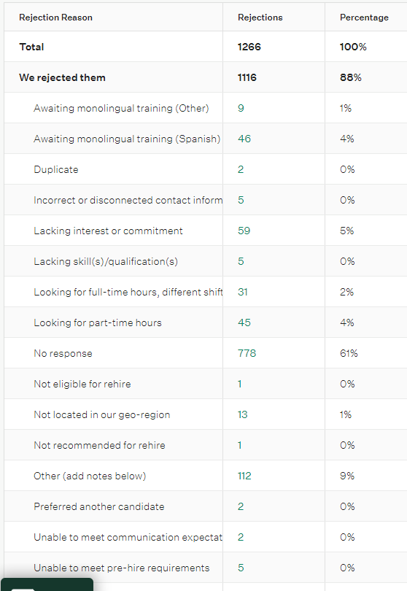

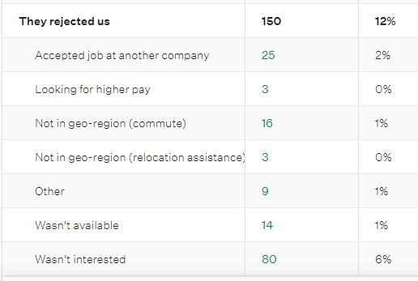

Based on the data shown here, we see that a majority of the candidates (61%) are dispositioned for “no response.” Many candidates are being rejected due to being a no show to their pre-screen and display unresponsive patterns throughout the interview process. I would highly recommend the team to double check the phone numbers and emails on their profile to ensure that it is correct when we reach out. Grayscale chooses a random number that populates on a candidate’s Greenhouse profile. Because a candidate may have been a re-applicant, migrated from Paycor, or have disconnected contact information, the automated reminder texts and emails will be sent to a phone number that no longer exists. By confirming that the phone number is correct, we can ensure the candidate has received a confirmation and reminder text for their phone screen.

We may also want to consider implementing a short survey at the end of the pre-screen process to determine candidate engagement and improve our process based on their feedback. This can be sent after a phone screen is completed in full. We can likely replace the job application button with this survey.

**Number of Applicants Dispositioned in Pre-Screen Stage (Q2)**

**Number of Applicants Dispositioned in Pre-Screen Stage (Q3)**

From Q2 to Q3, we see an 11% increase in the unresponsiveness of our candidates. This is likely due to the fall school semester starting and we are unable to retain the talent pool. In addition to this, a 6% total of individuals are rejected due to being unable to meet our scheduling requirements. Due to the nature of New Hire Training, it may overlap with their school schedule. Continuing to reassure candidates and encouraging them to reapply in the future is beneficial for our team. As of the start of Q4, Part-Time New Hire Training is no longer being offered. This greatly contributes to the number of rejections due to “looking for full-time hours, different shifts” and “looking for part-time hours.” This number will likely shrink once we have a New Hire Instructor dedicated to supporting part-time staff. We may also want to look into offering afternoon or evening shifts. This could mean allowing individuals to work 3-7pm at the latest. By allowing a 4-hour shift to work in the afternoon that overlaps with hours we serve the community, we can also reduce the number of dispositions for those who cannot commit to a full day shift. The number of individuals dispositioned in this stage can also be reduced through the use of pre-screening questions on the job application, as stated previously.

**Number of Applicants Dispositioned in Interview Stage (YTD)**

**Number of Applicants Dispositioned in Interview Stage (Q2)**

**Number of Applicants Dispositioned in Interview Stage (Q3)**

We see here that there is another 12% increase in the dispositions from Q2 to Q3 due to “no response,” likely caused by the fall school semester starting. To reduce the number of no shows here, we want to engage our top talent. At the end of the phone screen, we generally decide to schedule them for an in-person interview or hold off and follow up at a later date. During the time we speak to them about the in-person interview, we should reiterate the significance of the interview and its role in the candidate’s evaluation, making them feel that their presence is crucial. Recruiting team members should give candidates the overview of the group session and what to expect for the interview. By doing so, we can then elaborate on expectations and the rescheduling policies. We can once again provide this through a confirmation email and text, as we have been doing through the use of Grayscale and Greenhouse. Looking at the current templates we have for Greenhouse, including more details about the group interview may be very beneficial. Providing the candidates with clear and comprehensive information such as the interview format to help them prepare may also be advantageous for our candidates and the recruiting team to streamline the process. Including the links to our website with success stories, to videos, and more interactive materials will allow for greater engagement with the talent pool.

**Number of Applicants Dispositioned in Offer Stage (YTD)**

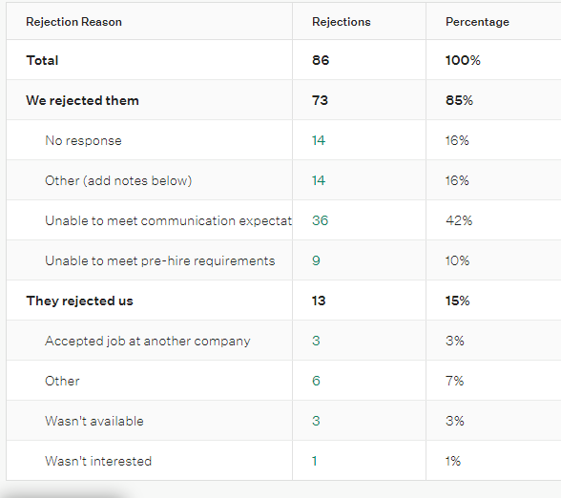

We see a majority of applicants are being dispositioned in the Offer Stage due to being unresponsive and/or an inability to meet communication expectations. We know that effective communication during the onboarding process for new hires is crucial for setting the stage for their success and integration into our organization. Through a revamp of the group pre-hire meetings, we may be able to attain better numbers and reduce the percentage of individuals dispositioned in the Offer stage. As noted in the first section, we want to create a more engaging onboarding process. There are a couple of strategies to implement here.

1. **Setting a clear point of contact:** We already assign a People Operations Coordinator as an HR representative for candidates in the pre-hire process. However, the candidates still end up calling the recruiters and service support specialists. During the pre-hire meeting, we should have the People Ops Coordinators’ names and contact information explicitly listed in the PowerPoint presentation and to reiterate that they would be their direct contact who can answer questions, provide guidance, and offer support during the onboarding process.
2. **Scheduling regular check-ins:** The current format of checking in with pre-hire candidates is usually through a phone call, email, and text throughout the work day. However, some candidates may be busy or it may be an inconvenient time for the People Ops Coordinator to speak if the candidate calls. I would recommend the team to leave space on their calendar open for a certain period of time (2-3 hours for around 2-3 days a week) and have candidates schedule their own check in through Calendly. This way, it mitigates any confusion and sets up a higher level of expectations during the onboarding process. It also helps our team organize our day and work much more efficiently. Candidates and People Operations Coordinators can then be ready to speak on a phone call to check in for around 15 minutes at a time. This can be an opportunity to assess their progress, provide personalized feedback and coaching. By recognizing that one size does not fit all, we can then tailor communication and onboarding experience to the individual needs and preferences of the candidate being onboarded.
3. **Providing essential information:** Ensuring the new hire has access to information such as company policies, benefits, and procedures via Greenhouse Onboarding as their centralized portal may prove to be beneficial. We should state that all the information for new hires are listed here should they have any questions.
4. **Programming a buddy or mentor into the process:** Pairing each new hire with a buddy our mentor such as another HCP going through the pre-hire steps at the same time can provide personalized guidance and support throughout the onboarding process. This can mean we can have 3 groups of 2 people in our group pre-hire meetings. Since they are going to have the same role, have individuals exchange contact information so they can support, encourage, and help one another before their start date. Greenhouse Onboarding displays a “Mentor” field on the candidate profile which can be anyone in our organization or who is currently onboarding.
5. **Introductions to the team:** As the HR team, we should connect new hires with other team members and key colleagues such as Care Supervisors through short virtual calls. Because Community Care is not involved in the recruiting process, it may be beneficial to start allowing teams to meet possible new team members during the onboarding process. Encouraging these informal interactions can help build relationships, especially if the HCP is meeting their possible supervisor. Building and fostering these relationships early on can definitely give the new hires something to look forward to.
6. **Reiterating the expectations and importance of pre-hire:** In our case, we extend a conditional job offer, pending the completion of pre-hire requirements. Although we have already covered this in the Group Session and in the Offer call, we should bring it up once again in the Pre-Hire meetings. Being very transparent with them will help alleviate some of the concerns we have later down the line. Every team member should state explicitly what the expectations are once again, and the consequences of not being able to meet these expectations. Laying out the foundation and executing it in full will not only be advantageous for candidates to know what to expect, but also for us to keep ourselves accountable.

**Number of Applicants Dispositioned in Offer Stage (Q2)**

**Number of Applicants Dispositioned in Offer Stage (Q3)**

**Number of Applicants Dispositioned, Rejection Reason (YTD)**

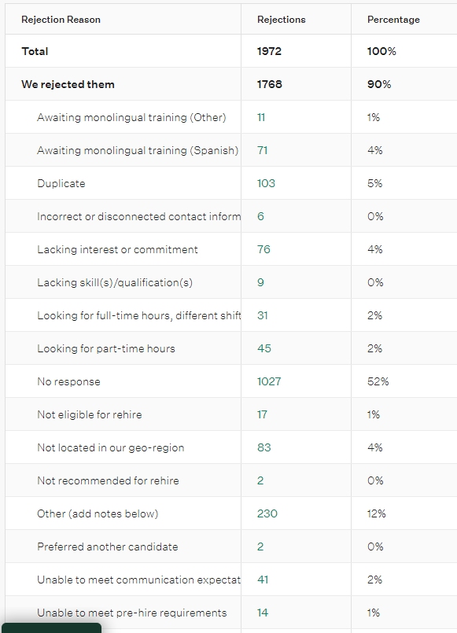

Once again, we see that over half (52%) of the candidates are dispositioned due to “no response.” This number is inevitably going to rise as we build a larger pipeline. However, the ratio of dispositions will stay nearly the same moving forward. If we’re able to generate more leads through process improvement and outreach, we can expect a greater number of candidates that are being hired as well as being rejected due to being unresponsive. This could be through additional headcount, including another VESL Recruiter and/or a Sourcer. For example, if we have a ratio for total candidates rejected to candidates rejected due to no response of ~2000:1000 this year, we may see ~2500:1250 next year. Overall, we will have more candidates being hired in the long term which is excellent for meeting the business goals.

**List of Hires (YTD)**

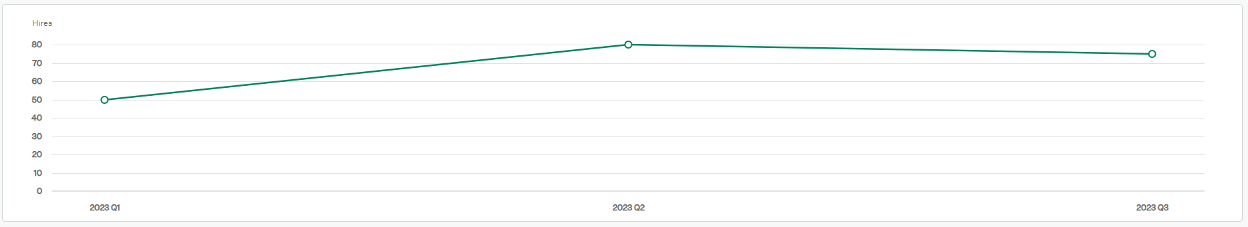

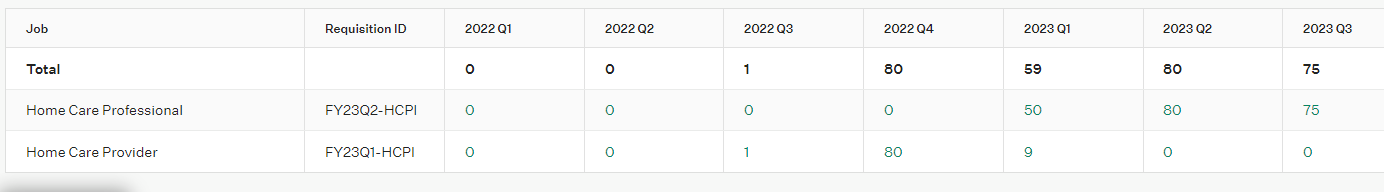

I included a snippet of data from 2022 Q4, because that was when we first started using Greenhouse. It also allows for a more accurate comparison between quarters. That being said, the number of hires from 2022 Q4 and 2023 Q2 are exactly the same. We should consider implementing measurable goals for the recruiting team. Because the average number of hires per quarter in the past year is ~74, we should make this our goal as a team. With the new strategies to implement, I believe that meeting and exceeding this goal is attainable.

**Average Time to Hire (YTD): 55 days**

One thing to consider is that the Application Review and Hiring Manager Review stages are generally under our control. Since applicants are only staying there for 2 and 3 days, respectively, the recruiting team is doing an excellent job at moving quickly through the pipeline. Some individuals may be in the Hiring Manager Review stage for 1 or 2 days longer because of unresponsiveness, in which we would disposition them after 3 business days. If we chose to reduce the average days in the review stages to 1 day, it may take a toll on the team’s ability to perform well and create an informed hiring decision. Because we typically give candidates a second chance to reschedule their interviews for the following week, they end up staying in these stages for 14 days at most.

Candidates are staying in the Offer stage for a significant period of time, around an average of 33 days. The reason for this would be due to the barriers that candidates experience during the onboarding process. Due to technical difficulties or personal barriers that come up, candidates may also drop out of the process. Many of the candidates are left in this Offer stage for a long time because of the way Greenhouse Recruiting is built. Those who are not yet hired but are onboarding will need about 2 weeks, or 14 days to commit to their pre-hire process and then become confirmed for New Hire Orientation. Given that candidates are scheduled for a pre-hire meeting the following week from the offer, then requiring an additional 14 days to submit their documentation, we should aim for keeping those in this Offer stage for 21 days. As we hire immediately after offer letters are signed, this number will significantly decrease because newly “hired” candidates move directly into Greenhouse Onboarding. However, individuals may still be in the pre-hire process for up to 3 weeks at a time. Since we allow 3 business days for candidates to sign their offer letter, we are looking to see the average days in the Offer stage reduce from 33 to 3.